 | Description | Ideas for development in solar Asset Management
 | Target Plan | 30–45 Days
 | Date | 05/19/2026
SolarOps AI Assistant
Project
Internal chatbot for monitoring engineers.
Features
Ask:
- “How to handle inverter offline?”
- “What is PR calculation?”
- “What to do for grid fault?”
Tech
- OpenAI API or local embeddings
- PDF/document search
Business Value
Knowledge management.
SolarOps AI Assistant
Project Proposal & Full Idea Document
Project Name
Astra AI – SolarOps AI Assistant
AI-powered internal chatbot for solar monitoring engineers and O&M teams.
1. Project Overview
The Monitoring SOP Assistant is an internal AI chatbot designed to help monitoring engineers quickly access Standard Operating Procedures (SOPs), troubleshooting steps, formulas, alarm handling processes, and operational guidelines.
Instead of searching through multiple PDFs, Excel files, emails, or manuals, engineers can simply ask questions in natural language.

Example queries:
- “How to handle inverter offline?”
- “What is PR calculation?”
- “How to identify string outage?”
- “What to do during grid fault?”
- “How to raise a ticket for communication loss?”
- “What is the formula for CUF?”
- “How to calculate post-curtailment forecast?”
The chatbot provides:
- SOP steps
- Technical explanations
- Escalation matrix
- Relevant formulas
- Document references
- Troubleshooting flow
2. Problem Statement
Currently in monitoring operations:
- SOPs are scattered across PDFs, SharePoint, emails, and Excel files.
- New engineers require long training periods.
- Engineers depend heavily on senior team members.
- Troubleshooting consistency varies across shifts.
- Important procedures are difficult to find quickly during incidents.
This causes:
- Increased MTTR (Mean Time to Resolution)
- Delayed issue handling
- Knowledge dependency
- Training overhead
- Operational inefficiency

3. Proposed Solution
Develop an AI-based internal knowledge assistant that:
- Reads internal SOP documents
- Understands technical queries
- Provides instant answers
- Searches multiple documents intelligently
- Gives step-by-step troubleshooting guidance
- Works like ChatGPT for internal monitoring operations
4. Core Features
A. AI Question Answering
Engineers can ask questions naturally.
Examples:
User Query | Chatbot Response
“Inverter offline procedure?” | SOP steps for inverter troubleshooting
“Grid fault handling” | Grid fault diagnosis process
“What is PR?” | PR definition + formula
“What causes low yield?” | Possible reasons + checks
“How to identify tracker issue?” | Diagnostic steps

B. SOP Search Engine
Search across:
- SOP PDFs
- RCA documents
- Incident reports
- OEM manuals
- Monitoring guidelines
- Shift handover documents
AI retrieves the most relevant content.
C. Formula Assistant
Supports technical calculations:
Examples
- PR Formula
- CUF Formula
- Availability Formula
- Specific Yield
- Post-curtailment Forecast
- Performance Loss
Example:
$$PR=\frac{Actual Energy}{Irradiance×Installed Capacity}$$
D. Troubleshooting Guidance
Step-by-step workflows.
Example:
Inverter Offline
- Check communication status
- Verify inverter ping
- Check breaker/trip status
- Verify site availability
- Contact site technician
- Raise OEM ticket if required
E. Smart Document Reference
The chatbot can show:
- SOP document source
- Page number
- Related files
- Relevant screenshots
F. User Role-Based Access
Different access levels:
- Monitoring Engineer
- Shift Lead
- O&M Manager
- Admin
G. Learning System
Future enhancement:
- Learn from resolved incidents
- Improve answers over time
- Build operational knowledge base
5. Suggested Tech Stack
Frontend
- React.js
- Next.js
- Tailwind CSS
Backend
- Python FastAPI / Node.js
- REST APIs
AI Layer
Option 1:
- OpenAI GPT API
Option 2:
- Local LLM (Llama 3 / Mistral)
Vector Database
- ChromaDB
- Pinecone
- FAISS
Embedding Models
- OpenAI Embeddings
- Sentence Transformers
Document Processing
- LangChain
- LlamaIndex
- PyPDF
Authentication
- Microsoft SSO / Google OAuth
Deployment
- Azure
- AWS
- On-premise server
6. System Architecture
User
↓
Web Chat Interface
↓
Backend API
↓
AI Engine (GPT / LLM)
↓
Vector Database
↓
SOP PDFs / Manuals / Reports

7. Workflow
Step 1
Upload SOPs and technical documents.
Step 2
System converts documents into embeddings.
Step 3
Engineer asks a question.
Step 4
AI searches relevant SOP sections.
Step 5
AI generates accurate response.
8. Example Use Cases
Use Case 1 – Inverter Fault
Query
“ABB inverter offline at night. What to check?”
Response
- Verify communication gateway
- Check SCADA availability
- Confirm inverter startup timing
- Verify DC voltage presence
- Escalation procedure
Use Case 2 – PR Calculation
Query
“What is PR calculation?”
Response
PR= ( Actual Energy​ / Reference Energy ) × 100
Explanation:
- Actual Energy = Measured generation
- Reference Energy = Irradiance-based theoretical generation
Use Case 3 – Grid Fault
Query
“How to handle grid fault alarm?”
Response
- Verify plant-wide outage
- Check utility status
- Review breaker condition
- Confirm substation communication
- Notify grid operator if required
9. Business Value
A. Faster Incident Resolution
Reduces troubleshooting time significantly.
B. Knowledge Management
Centralized operational knowledge repository.
C. Reduced Training Time
New engineers can learn independently.
D. Standardized Operations
Ensures SOP compliance across all shifts.
E. 24/7 Knowledge Availability
AI assistant always accessible.
F. Reduced Dependency on Senior Engineers
Knowledge becomes organizational instead of individual.
10. Future Enhancements
Phase 2 Ideas
Voice Assistant
“Hey Astra, explain inverter trip.”
WhatsApp / Teams Integration
Ask SOP questions directly in Teams.
Alarm Auto-Recommendation
AI suggests actions automatically when alarms occur.
SCADA Integration
Fetch live plant alarms.
Incident RCA Generator
Generate root cause analysis drafts.
Multi-language Support
English + German + Hindi.
AI Ticket Generator
Automatically create OEM tickets.
11. Security & Compliance
- Internal access only
- Role-based permissions
- Document encryption
- Audit logs
- API security
- No external sharing
12. Suggested Development Timeline (30–45 Days)
Week | Activity
Week 1 | Requirement gathering + UI design
Week 2 | PDF ingestion + embeddings
Week 3 | Chatbot backend integration
Week 4 | Testing + optimization
Week 5 | Deployment
Week 6 | User training + enhancements

13. Recommended MVP Scope
For intern/student project:
Include
- Chat UI
- PDF upload
- SOP search
- Basic AI answers
- Formula support
- Authentication
Exclude Initially
- SCADA integration
- Voice AI
- Live alarms
- Multi-language
14. Sample Dashboard Modules
Left Sidebar
- SOP Categories
- Recent Queries
- Saved Procedures
Main Chat Window
- User questions
- AI responses
- Reference documents
Admin Panel
- Upload SOPs
- Manage users
- View usage analytics

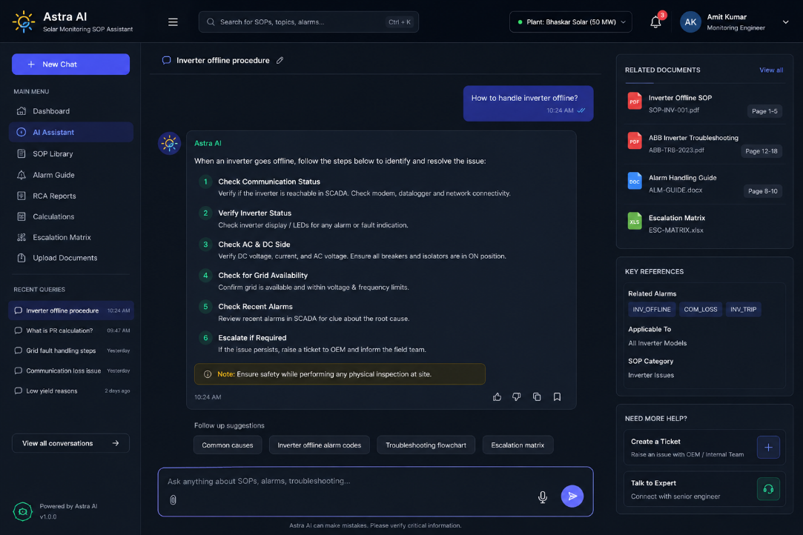
15. KPI Improvements After Implementation
KPI | Expected Improvement
Incident Resolution Time | ↓ 30–40%
Training Time | ↓ 50%
SOP Search Time | ↓ 80%
Knowledge Dependency | ↓ Major Reduction
Shift Escalations | ↓ Reduced

16. Recommended Project Deliverables
The intern/developer should deliver:
- Working chatbot UI
- PDF ingestion system
- AI Q&A engine
- SOP search functionality
- User authentication
- Deployment documentation
- Technical architecture document
- User manual
- Demo presentation
17. Suggested Project Names
- Astra AI SOP Assistant
- AGAS Knowledge AI
- SolarOps GPT
- MonitorMind AI
- HelioAssist
- SunDesk AI
- O&M Copilot
18. Recommended Open-Source Stack (Low Cost)
Component | Tool
LLM | Llama 3
Vector DB | ChromaDB
Backend | FastAPI
Frontend | React
Embeddings | Sentence Transformers
PDF Parsing | PyPDF
Deployment | Docker

19. Final Recommendation
This is a highly practical and industry-relevant AI project for a solar monitoring company because it directly improves:
- Operational efficiency
- Knowledge accessibility
- Incident response
- Engineer productivity
- SOP standardization
It is also scalable into a full AI operations platform in the future.

